System Requirements Statement (SRS) –

Art For Welfare

Doc. Ref. :

Version : 0.4

Status : Drafted

Created by : Kenji Tanaka

Date : 04-Dec-2012

1. Introduction 3

2. Functional Requirements 4

2.1 Artist Module

2.2 Customer Module

2.3 Admin Module

2.4 NGO module

2.5 Message Acknowledgement Module

2.6 Use Case Diagram

THIS DOCUMENT CONTAINS 23 NUMBERED PAGES

# Introduction

This document explains the system requirements and scope for developing art For welfare system .

Art for Welfare system could divide the five main parts, Artist part, Customer part, Admin part, NGO and the acknowledgement part.

This document describes the system requirement of the Account part.

# Functional Requirements

The Account part of Art For Welfare has three modules which are divided 13 processes described as below.

|  |  |  |
| --- | --- | --- |
| **No** | **BRS requirement ID** | **Description** |
| **2.1** | **Artist Module** | |
| **2.1.1** | **F1** | **Account Creation Process** |
| **2.1.2** | **F2** | **Login Process** |
| **2.1.3** | **F3** | **Forgot Password Process** |
| **2.1.4** | **F4** | **Change Password Process** |
| **2.1.5** | **F5** | **Update Account Process** |
| **2.1.6** | **F6** | **Search Art** |
| **2.1.7** | **F7** | **Publish Art for sale** |
| **2.1.8** | **F8** | **Update Art Information** |
| **2.1.9** | **F9** | **Delete Art** |
| **2.2** | **Customer Module** | |
| **2.2.1** | **F11** | **Account Creation Process** |
| **2.2.2** | **F12** | **Login Process** |
| **2.2.3** | **F13** | **Forgot Password Process** |
| **2.2.4** | **F14** | **Change Password Process** |
| **2.2.5** | **F15** | **Update Account Process** |
| **2.2.6** | **F16** | **Search Art** |
| **2.2.7** | **F17** | **Buy Art** |
| **2.2.8** | **F18** | **Cancel cart** |
| **2.2.9** | **F19** |  |
| **2.3 Admin Module** | | |
| **2.3.1** | **F21** | **Login Process** |
| **2.3.2** | **F22** | **Forgot Password Process** |
| **2.3.3** | **F23** | **Change Password Process** |
| **2.3.4** | **F24** | **Update Account Process** |
| **2.3.5** | **F25** | **Report Generation** |
| **2.3.6** | **F26** | **Accounts Management** |
|  |  |  |
| **2.4 NGO Module** | | |
| **2.4.1** | **F27** | **Account Creation Process** |
| **2.4.2** | **F28** | **Login Process** |
| **2.4.3** | **F29** | **Forgot Password Process** |
| **2.4.5** | **F30** | **Change Password Process** |
| **2.4.6** | **F31** | **Update Account process** |
| **2.4.7** | **F32** | **View Funds** |

## Artist Module

* Artist is the user of system who wants to sell the Art.

### Account Creation Process

* Art For Welfare System compels to create the account before using it. So, Art For Welfare System should provide the function which makes Artist creates new account.
* When Artist creates new account, the function demands information described as below.

1. Login information
2. Contact Details.

* The Login information

The Login information consists of some items described as below.

1. UserID
2. Password
3. First Name
4. Last Name
5. E-mail address
6. User Type
   * All items are compulsorly demanded.
   * UserID

* The UserID should be unique. If the UserID correspond with not case-sensitive to other which is previously registered, the UserID should not be registered as an account.
  + Password
* The Password has constrains which makes the Password consists of more than or equal 8 and less than or equal 16 characteristics including characters described as below.

1. Numeric figure (at least one)
2. Capital alphabet (A-Z)(at least one)
3. Small alphabet (a-z)(at least one)
4. Special character (#, $, %, &, etc.) (at least one)

* The Password is masked by dummy characters. The re-entering Password is demanded.
* The Password must be encrypted in Art For Welfare System.
  + User Type

The User Type falls into below categories.

1. Artist
2. Customer
3. NGO

* The User Type defines also three types of user; "Artist", "Customer" and ”NGO” .
* In an Account Creation Process, the user can select Artist.
* No one can select The Administrator, because Administrator is implemented to Art For Welfare System in advance.
* Contact Details
* The Contact Detail consists of some items described as below.

1. Permanent Address
2. Contact Phone No
   * All items are compulsory demanded.
   * Permanent Address

* Permanent Address should be filled.
* But only the state should be selected from options.
* The Security Question information

The Security Question information is needed when Artist lost their Password. This information consists of two items described as below.

1. Selected Question
2. Answer
   * All items are compulsory demanded.
   * Some questions which are difficult to answer for anyone else are prepared in advance.

E.g. which color do you like most?

* + A question should be selected from options by the Artist, and the Answer is registered by the Artist.
* Login information should be entered on one screen, and then Artist information and Security Question information should be entered on another screen.

### Login Process

* Art For Welfare System always compels user authentication before using itself except when a new account is successfully created.
* The user authentication demands UserID and Password. The UserID and the Password should be checked in three ways.
  + First, The UserID and the Password should be existed and correct.
* If The UserID and the Password are not equal to what the user has registered, the user authentication cannot be provided.
  + Second, the User Type linked to the UserID should be "Artist".
* When the User Type is "Artist", then user can be placed on “Artist Home”.
  + Finally, UserID should be available.
* The Administrator can decide whether the UserID is available or suspended – Refer to the SRS of the Admin part.
* If Artist is rejected, user authentication is not provided for system user.
* The Artist account should alive for so long as the duration decided by Admin.
* Only when the three checks are successfully completed, Artist can be placed on respected page.
* The “Artist Home” provides the some items described as below.

1. A trigger to logout.
2. A trigger to update Account.
3. A trigger to Change Password.
4. A trigger to Search Art.
5. A trigger to Publish Art for sale.
6. A trigger to Update Art Information.
7. A trigger to Delete Art.

### Forgot Password Process

* When system user lost their Password, the recovery method should be provided by Art For Welfare system.

The recovery method is described as below.

* + First, system user enters their UserID for Art For Welfare System.
  + Next, Art For Welfare System demands the Answer which has been registered since when the Account was created.
  + Only when the Answer is correct, Artist get the new password by E-mail which also has been registered since when the Account was created.
  + The new password is automatically generated by Art For Welfare System.
* Of course, the new password should consist of more than or equal 8 and less than or equal 16 characteristics including at least a numeric figure, a capital alphabet, a small alphabet, and a special character.
* As a consequence, The Artist could get the Artist authentication using the new password.
  + Then, the Artist had better change the new password manually.
* If the Answer is not correct, otherwise, the correct Answer is demanded for user again.
  + In that case, Of course, Artist couldn’t get the new password.

### Change Password Process

* When Artist wants to change their Password, the measure should be provided by Art For Welfare System.
* Therefore, Art For Welfare System should provide the function which is available after getting the Artist authentication.
* The function demands the current password and the new password.
  + Of course, the new password should consist of more than or equal 8 and less than or equal 16 characteristics including at least a numeric figure, a capital alphabet, a small alphabet, and a special character.
  + The current password and the new password are masked by using dummy characters.
  + The new password is demanded to enter twice to avoid a typing error.
* Only when the current password is correct, Artist could change their Password.
* When the current password is changed into new password, Art For Welfare System compels user authentication again.

### Update Account Process

* Art For Welfare System should provide the function which makes the account updated for Artist.
* The information Artist could update is described below.

1. Login information
2. User information
3. Security Question Information

* The Login information

The updatable items as described below.

1. First Name
2. Last Name
3. E-mail address
   * All items are compulsory demanded, but updating is optional.

* The User information

The updatable items as described below.

1. User Name
2. User Phone No
3. E-mail address
4. Permanent address
   * All items are compulsory demanded, but updating is optional.

* The Security Question information

The updatable items as described below.

1. Selected Question
2. Answer
   * All items are compulsory demanded, but updating is optional.

### Search Art

* Search conditions are described as below.

1. Art category
2. Price range

### Publish Art for sale

* Publish Arts requirements are described as below.

1. Art category
2. Price
3. Art name
4. Quantity
5. Photos

* Artist can see market prices before publishing Arts.

### Update Art information

* After publishing the Art, Artist can only update following contents.

1. Art quantity.
2. Art price.

### Delete Art

• After Publishing if Artist wants to remove some Arts then he can delete the Art.

## Customer Module

### Account Creation Process

* Art For Welfare System compels to create the account before using it. So, Art For Welfare System should provide the function which makes Artist creates new account.
* When Artist creates new account, the function demands four information described as below.

1. Login information
2. First name
3. Last name

4.Contact Details

5.Security Question Information

6.Payment information.

* The registration information

The registration information consists of some items described as below.

1. Login information
2. First name
3. Last name

4. Contact Details

5. Security Question Information

6. Payment information.

7.UserID

8.Password

* + All items are compulsory demanded.
  + UserID
* The UserID should be emailId.
  + Creation of password Password
* The Password has constrains which makes the Password consists of more than or equal 8 and less than or equal 16 characteristics including characters described as below.

1.Numeric figure (at least one)

2.Capital alphabet (A-Z)(at least one)

3.Small alphabet (a-z)(at least one)

4.Special character (#, $, %, &, etc.) (at least one)

* The Password is masked by dummy characters. The re-entering Password is demanded.
* The Password must be encrypted in Art For Welfare System.
* Contact Details
* The Contact Detail consists of some items described as below.

1.Permanent Address

2.Contact Phone No

* + All items are compulsory demanded.
  + Permanent Address
* Permanent Address should be filled.
* But only the state should be selected from options.
* The Security Question information

The Security Question information is needed when Customer lost their Password. This information consists of two items described as below.

1. Selected Question
2. Answer
   * Some questions which are difficult to answer for anyone else are prepared in advance.

E.g. which color do you like most?

* + A question should be selected from options by the Customer, and the Answer is registered by the Customer.
* Login information should be entered on one screen, and then Customer information and Security Question information should be entered on another screen.

### Login Process

* Art For Welfare System always compels Customer authentication before using itself except when a new account is successfully created.
* The user authentication demands UserID and Password. The UserID and the Password should be checked in three ways.
  + First, The UserID and the Password should be existed and correct.
* If The UserID and the Password are not equal to what the user has registered, the user authentication cannot be provided.
* The Customer account should alive for so long as the duration decided by Admin.
* Only when the three checks are successfully completed, Customer can be placed on respected page.
* The “Customer Home” provides the some items described as below.

1. A trigger to logout.
2. A trigger to update Account
3. A trigger to Change Password
4. A trigger to Search Art
5. A trigger to Add Art to cart
6. A trigger to Delete Art in cart

### Forgot Password Process

* When Customer lost their Password, the recovery method should be provided by Art For Welfare system.

The recovery method is described as below.

* + First, Customer enters their UserID for Art For Welfare System.
  + Next, Art For Welfare System demands the Answer which has been registered since when the Account was created.
  + Only when the Answer is correct, Customer get the new password by E-mail which also has been registered since when the Account was created.
  + The new password is automatically generated by Art For Welfare System.
* Of course, the new password should consist of more than or equal 8 and less than or equal 16 characteristics including at least a numeric figure, a capital alphabet, a small alphabet, and a special character.
* As a consequence, The Customer could get the user authentication using the new password.
  + Then, the Customer had better change the new password manually.
* If the Answer is not correct, otherwise, the correct Answer is demanded for Customer again.
  + In that case, Of course, Customer couldn’t get the new password.

### Change Password Process

* When Customer wants to change their Password, the measure should be provided by Art For Welfare System.
* Therefore, Art For Welfare System should provide the function which is available after getting the Customer authentication.
* The function demands the current password and the new password.
  + Of course, the new password should consist of more than or equal 8 and less than or equal 16 characteristics including at least a numeric figure, a capital alphabet, a small alphabet, and a special character.
  + The current password and the new password are masked by using dummy characters.
  + The new password is demanded to enter twice to avoid a typing error.
* Only when the current password is correct, Customer could change their Password.
* When the current password is changed into new password, Art For Welfare System compels Customer authentication again.

### Update Account Process

* Art For Welfare System should provide the function which makes the account updated for Customer.
* The information Customer could update is described below.

1. Login information

2. User information

3. Security Question Information

* The Login information

The updatable items as described below.

1. First Name
2. Last Name
3. E-mail address
   * All items are compulsory demanded, but updating is optional.

* The User information

The updatable items as described below.

1. User Name
2. User Phone No
3. E-mail address
4. Permanent address
   * All items are compulsory demanded, but updating is optional.

* The Security Question information

The updatable items as described below.

1. Selected Question
2. Answer
   * All items are compulsory demanded, but updating is optional.

### Search Art

• Search conditions are described as below.

1. Art category

2. Price range

• As the result of searching Requirements, Customer could see the list of Arts which are available for sale.

1. Art name

2. Price

3. Quantity

4. Photos

### Buy Art

• To buy the Art followings are the condition

1. Art category

2. Price range

3. Art Quantity

4. Art Name

### Cancel Cart

• Before paying Customer can cancel the order in following condition

1. If the product does not fulfil the requirement.

2. If price goes out of his budget.

## Admin Module

**•** Administratorshould be responsible for following activities**,**

### Login Process

* Art For Welfare System always compels user authentication before using itself except when a new account is successfully created.
* The user authentication demands UserID and Password. The UserID and the Password should be checked in three ways.
  + First, The UserID and the Password should be existed and correct.
* If The UserID and the Password are not equal to what the admin has registered, the Admin authentication cannot be provided.
  + Second, the User Type linked to the UserID should be "Admin".
* When the User Type is "Admin", user can be placed on “Admin Home”.
  + Finally, UserID should be available.
* The Administrator can decide whether the UserID is available or suspended – Refer to t
* .0he SRS of the Admin part.
* If user is rejected, user authentication is not provided for system user.
* The Admin account should alive for so long as the duration decided by Admin.
* Only when the three checks are successfully completed, Admin can be placed on respected page.
* The “Admin Home” provides the some items described as below.

1. A trigger to logout
2. A trigger to update Account
3. A trigger to Change Password
4. A trigger to Search Art
5. A trigger to Publish Art for sale
6. A trigger to Update Art Information
7. A trigger to Delete Art
8. A trigger to Browse existing Market price

### Forgot Password Process

* When Admin lost their Password, the recovery method should be provided by Art For Welfare system.

The recovery method is described as below.

* + First, Admin enters their UserID for Art For WelFare System.
  + He will enter the E-mail id since when the Account was created.
  + Only when the E-mail Id is correct, Admin get the new password by E-mail which also has been registered since when the Account was created.
  + The new password is automatically generated by Art For Welfare System.
* Of course, the new password should consist of more than or equal 8 and less than or equal 16 characteristics including at least a numeric figure, a capital alphabet, a small alphabet, and a special character.
* As a consequence, The Admin could get the Admin authentication using the new password.
  + Then, the Admin had better change the new password manually.

### Change Password Process

* When Admin wants to change his Password, the measure should be provided by Art For Welfare System.
* Therefore, Art For WelFare System should provide the function which is available after getting the Admin authentication.
* The function demands the current password and the new password.
  + Of course, the new password should consist of more than or equal 8 and less than or equal 16 characteristics including at least a numeric figure, a capital alphabet, a small alphabet, and a special character.
  + The current password and the new password are masked by using dummy characters.
  + The new password is demanded to enter twice to avoid a typing error.
* Only when the current password is correct, Admin could change his Password.
* When the current password is changed into new password, Art For WelFare System compels user authentication again.

### Update Account Process

* Art For WelFare System should provide the function which makes the account updated for Admin.
* The information Admin could update is described below.

1. Login information
2. User information
3. Security Question Information

* The Login information

The updatable items as described below.

1. First Name
2. Last Name
3. E-mail address
   * All items are compulsory demanded, but updating is optional.

* The User information

The updatable items as described below.

1. User Name
2. User Phone No
3. E-mail address
4. Permanent address
   * All items are compulsory demanded, but updating is optional.

* The Security Question information

The updatable items as described below.

1. Selected Question
2. Answer
   * All items are compulsory demanded, but updating is optional.

### Report Generation

• Admin should be able to see all the records from any users.

• Daily report of enrolment to admin.

• Monthly report of enrolment as per the states to admin.

### Accounts Management

• Admin should able to manage all the accounts with following activities,

1. Enable accounts(artist ,customer , NGO)

2. Disable accounts(artist, customer, NGO)

## NGO Module

### Account Creation Process

* Art For Welfare System compels to create the account before using it. So, Art For Welfare System should provide the function which makes Artist creates new account.
* When Artist creates new account, the function demands information described as below.

1. Login information

2. Contact Details.

* The Login information

The Login information consists of some items described as below.

1. UserID
2. Password
3. First Name
4. Last Name
5. E-mail address
6. User Type
   * All items are compulsorly demanded.
   * UserID

* The UserID should be unique. If the UserID correspond with not case-sensitive to other which is previously registered, the UserID should not be registered as an account.
  + Password
* The Password has constrains which makes the Password consists of more than or equal 8 and less than or equal 16 characteristics including characters described as below.

1. Numeric figure (at least one)
2. Capital alphabet (A-Z)(at least one)
3. Small alphabet (a-z)(at least one)
4. Special character (#, $, %, &, etc.) (at least one)

* The Password is masked by dummy characters. The re-entering Password is demanded.
* The Password must be encrypted in Art For Welfare System.
  + User Type

The User Type falls into below categories.

1. Artist
2. Customer
3. NGO

* The User Type defines also three types of user; "Artist", "Customer" and ”NGO” .
* In an Account Creation Process, the user can select Artist.
* No one can select The Administrator, because Administrator is implemented to Art For Welfare System in advance.
* Contact Details
* The Contact Detail consists of some items described as below.

1. Permanent Address
2. Contact Phone No
   * All items are compulsory demanded.
   * Permanent Address

* Permanent Address should be filled.
* But only the state should be selected from options.
* The Security Question information

The Security Question information is needed when Artist lost their Password. This information consists of two items described as below.

1. Selected Question
2. Answer
   * All items are compulsory demanded.
   * Some questions which are difficult to answer for anyone else are prepared in advance.

E.g. which color do you like most?

* + A question should be selected from options by the Artist, and the Answer is registered by the Artist.
* Login information should be entered on one screen, and then Artist information and Security Question information should be entered on another screen.

### Login Process

* Art For Welfare System always compels user authentication before using itself except when a new account is successfully created.
* The user authentication demands UserID and Password. The UserID and the Password should be checked in three ways.
  + First, The UserID and the Password should be existed and correct.
* If The UserID and the Password are not equal to what the user has registered, the user authentication cannot be provided.
  + Second, the User Type linked to the UserID should be "Artist".
* When the User Type is "Artist", then user can be placed on “Artist Home”.
  + Finally, UserID should be available.
* The Administrator can decide whether the UserID is available or suspended – Refer to the SRS of the Admin part.
* If Artist is rejected, user authentication is not provided for system user.
* The Artist account should alive for so long as the duration decided by Admin.
* Only when the three checks are successfully completed, Artist can be placed on respected page.
* The “Artist Home” provides the some items described as below.

1. A trigger to logout.
2. A trigger to update Account.
3. A trigger to Change Password.
4. A trigger to Search Art.
5. A trigger to Publish Art for sale.
6. A trigger to Update Art Information.
7. A trigger to Delete Art.

### Forgot Password Process

* When system user lost their Password, the recovery method should be provided by Art For Welfare system.

The recovery method is described as below.

* + First, system user enters their UserID for Art For Welfare System.
  + Next, Art For Welfare System demands the Answer which has been registered since when the Account was created.
  + Only when the Answer is correct,NGO get the new password by E-mail which also has been registered since when the Account was created.
  + The new password is automatically generated by Art For Welfare System.
* Of course, the new password should consist of more than or equal 8 and less than or equal 16 characteristics including at least a numeric figure, a capital alphabet, a small alphabet, and a special character.
* As a consequence, The Artist could get the Artist authentication using the new password.
  + Then, the Artist had better change the new password manually.
* If the Answer is not correct, otherwise, the correct Answer is demanded for user again.
  + In that case, Of course, Artist couldn’t get the new password.

### Change Password Process

* When NGO wants to change their Password, the measure should be provided by Art For Welfare System.
* Therefore, Art For Welfare System should provide the function which is available after getting the Artist authentication.
* The function demands the current password and the new password.
  + Of course, the new password should consist of more than or equal 8 and less than or equal 16 characteristics including at least a numeric figure, a capital alphabet, a small alphabet, and a special character.
  + The current password and the new password are masked by using dummy characters.
  + The new password is demanded to enter twice to avoid a typing error.
* Only when the current password is correct, NGO could change their Password.
* When the current password is changed into new password, Art For Welfare System compels user authentication again.

### Update Account Process

* Art For Welfare System should provide the function which makes the account updated for NGO.
* The information NGO could update is described below.

1. Login information
2. User information
3. Security Question Information

* The Login information

The updatable items as described below.

1. First Name
2. Last Name
3. E-mail address
   * All items are compulsory demanded, but updating is optional.

* The User information

The updatable items as described below.

1. User Name
2. User Phone No
3. E-mail address
4. Permanent address
   * All items are compulsory demanded, but updating is optional.

* The Security Question information

The updatable items as described below.

1. Selected Question
2. Answer
   * All items are compulsory demanded, but updating is optional

### View Funds

* NGO will be able to see fund received.
* NGO will be able to track fund month wise year wise
* Ngo will be able to track a fund received for specific period.

## Message Acknowledgement Module

• In following conditions acknowledgement to be send

1. After completion of successful registration.
2. After every successful transaction (buy, sale).
3. Now the messages are being sent by using email but in future we can have mobile sms.

## Use Case Diagram

### Admin:

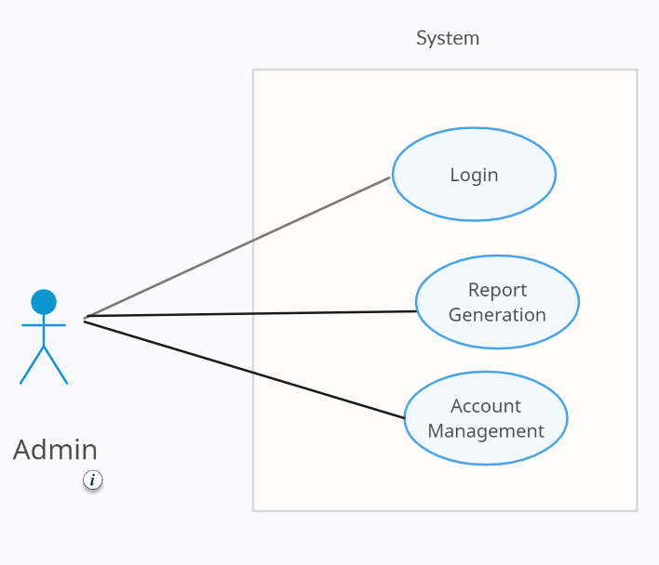

*Fig. Use case diagram for admin*

1. In Admin use case diagram Admin is the Actor.
2. Admin can handle following use cases:
3. Login
4. Report Generation
5. Account Management

### Artist

1. In Artist use case diagram Artist is the Actor.
2. Artist can handle following use cases:
3. Register
4. Login
5. Search Art
6. Publish Art
7. Update Art
8. Delete Art
9. Browse Art Price

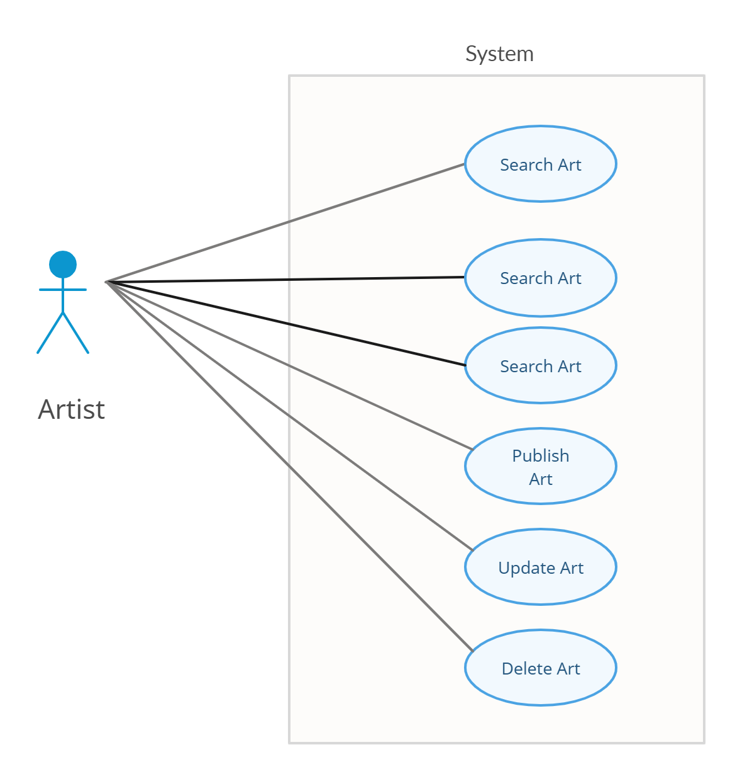

*Fig. Use case diagram for Artist*

### Customer

1. In Customer use case diagram Customer is the Actor**.**
2. Customer can handle following use cases:
3. Register
4. Login
5. Search Art
6. Buy Art
7. Payback
8. Cancel Order
9. Browse Art Price

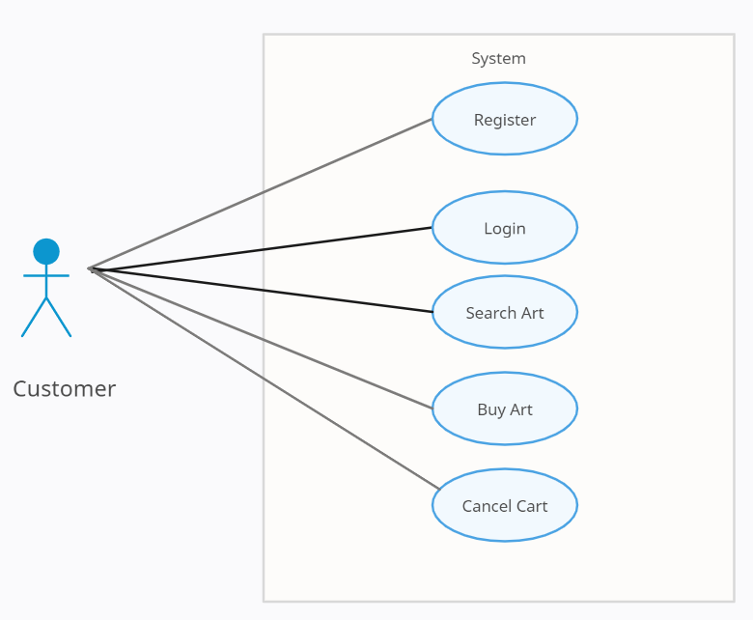

*Fig. Use case diagram for Customer*

### NGO

